Surveyor Manual

MCC Kosovo WORKfoRce and time use survey

March 20, 2017

Contents

Background 2

Research Purpose 2

Definitions 3

The Eurostat Method 4

Sample Selection 5

Household Listing 6

Household Visits 6

Data Collection Tools 6

Pre-screening 7

Respondent Compensation 7

Using SurveyCTO 8

Human Subjects Research Protections 12

Data Quality Assurance 13

Tracking Protocols 14

Enumerator Conduct 14

Interviewer Doorstep Techniques 16

Enumerator Responsibilities 18

Supervisor Responsibilities 19

Education Field Examples 19

TUS Coding Guidelines 22

Frequently Asked Questions (FAQs) 25

Annotated Questionnaires 26

# Background

Created by the U.S. Congress in January 2004 with strong bipartisan support, MCC is an innovative and independent U.S. foreign aid agency that is helping lead the fight against global poverty. This objective is achieved through the creation of partnerships with countries that are committed to good governance, economic freedom, and investments in their citizens. MCC provides these well-performing countries with large-scale grants to fund country-led solutions for reducing poverty through sustainable economic growth. There are two primary types of MCC grants: Compacts and Threshold Programs. Compacts are large, five-year grants for countries that pass MCC’s eligibility criteria and Threshold Programs are smaller grants awarded to countries that come close to passing these criteria and are firmly committed to improving their policy performance.

Kosovo was selected as eligible for MCC Compact Development in December 2015, and a National Coordinator and Chief Economist of the Core Team were appointed in May 2016. MCC and Core Teams have begun the process of identifying binding constraints to growth in Kosovo, and a series of consultations with a variety of stakeholders (including government officials, civil society organizations, and the private sector) were held in June 2016.

To further MCC’s objectives, MCC and Social Impact (SI)—a global development management consulting firm in the Washington D.C. area—signed a contract to conduct a nationally and regionally representative labor force and time use study in Kosovo in 2017. Social Impact subsequently subcontracted IDRA as its local data collection partner in Kosovo.

# Research Purpose

In order to facilitate reliable economic analysis to inform growth-oriented programming, MCC is supporting a study to explore dynamics around employment and time use among Kosovo’s resident population. Broadly speaking, the purpose of this study is to answer the following nine research questions for Kosovo:

* What is the true level of employment (formal and informal), underemployment or vulnerable employment, and unemployment, disaggregated by gender and district? How much time have the un- or under-employed spent looking for a job? Are they an entrepreneur?
* Is there a relationship between field of study and having employment? How many people are employed in the field that they studied? Are there any correlations between certain fields of study or location and unemployment?
* For people not looking for jobs, why are they not looking?
* What are people doing with their time? Especially, what are women or the unemployed doing with their time? How much time is spent on child care and elder care? How much time is spent commuting?
* How does receiving remittances and/or the ability to work abroad impact labor market decisions?
* How do attitudes about women's place in family and society influence women's participation in the labor market?
* How is women’s engagement in productive activities (like starting a business) related to ownership and ability to control assets/access to credit?
* Have discriminatory practices in hiring or while employed, or perceptions that there might be such practices, discouraged women from seeking jobs?
* What are the factors that inhibit entrepreneurship, especially for women vs. men, and lead to the low levels of entrepreneurial activity for men and/or women?

While IDRA is responsible for managing the data collection activity (with guidance and oversight from SI), SI will be responsible for analyzing and interpreting the data collected to ensure the above research questions are answered to the satisfaction of MCC.

# Definitions

An **Enumeration Area (EA)** is the smallest geographical statistical unit created for a housing and population census. For example, an EA can be a city block, a village or part of a village, or a group of small villages. The EA has well-defined boundaries identified on a map. The number of households per EA is generally small enough to be covered by one or two enumerators during the census. The size of the EAs is fairly uniform, although there is some variability in the number of households by EA. In Kosovo, the average size of EAs is different for urban and rural areas.

A **sketch map** is a map that was produced during the household listing operation that shows all of the current structures found within the boundaries of the EA. It also contains features such as landmarks (river, roads), public buildings (e.g. park, school, or temple) and streets or roads which helps the interviewer to find the selected households.

A **structure** is a free-standing building that can have one or more dwellings for residential, commercial, or other use. Residential structures can have one or more dwelling units (e.g., a single house or an apartment building).

A **dwelling unit** is a room or a group of rooms normally intended as a place of residence for one household (e.g., a single house, an apartment, or a group of rooms in a house). However, a dwelling unit can also be shared by more than one household.

A **household unit**: It is critical to distinguish between a household *dwelling*, which consists of physical structure(s)/space(s) as described above and a household *unit*, which consist of a single person or group of persons (related or unrelated) who share in household expenses spent on providing the household members with food and other essential items for living. Members of the group may pool their incomes to a greater or lesser extent. Shares in household expenses include benefiting from expenses (e.g., children or persons with no income) as well as contributing to expenses. Because households are defined as people or groups of people (rather than physical structures), it is possible for more than one household to reside in a single dwelling.

# The Eurostat Method[1]

The Eurostat method has emerged as the leading labor force survey implementation protocol, and is applied in this research context to ensure the collection of high quality data that fully captures the study’s nine research questions. Key Eurostat definitions as relevant to the Kosovo Labor Force and Time Use Study are outlined in the table below:

|  |  |
| --- | --- |
| **Variable/Term** | **Eurostat definition** |
| Employment (persons in employment) | Persons at least 15 years of age who during the reference week worked for at least one hour for pay or profit for family gain or who were not at work during the reference week, but had a job or business from which they were temporarily absent (applicable to employees, self-employed persons, and family workers). |
| Unemployment | Persons aged 15-74 years who were not employed during the definition of employment, currently available for work, or actively seeking work (had taken steps within the last four weeks to seek out paid employment. |
| Active population | The population employed or unemployed (also referred to as the labor force). |
| Economically inactive persons | Those who are neither employed or unemployed |

Given the complexity of the terms listed above, the Eurostat method stipulates that LFS respondents not be directly asked if they are employed, unemployed, or inactive. Instead, survey questions inquire about respondents’ labor market behavior during a given reference week, and their labor force status is derived from their responses. This methodology is illustrated in the flow chart below:

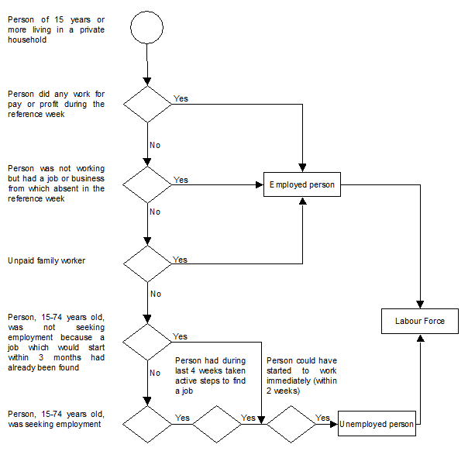

This derivation strategy and the appropriate skip logic is programmed into the instruments for the Kosovo Labor Force and Time Use Study.

# Sample Selection

Primary sampling units consist of geographic Enumeration Areas (EAs) as defined by the 2011 Population and Housing Census. Within each sampled EA, households will be randomly selected to participate in the survey. SI conducted sample size calculations to determine both the number of EAs and households required to ensure the survey data will be representative of key indicators of interest to MCC, and found that 854 EAs and 10 households per EA will be required for a total effective sample size of 8,540 households nationally. These 854 EAs will be evenly distributed across Kosovo’s seven regions (122 each) and have been stratified according to the number of urban/rural households. The 854 EAs have been randomly selected.

# Household Listing

In order to ensure the study is representative of Kosovo’s population, it is important that each household within the sampled EAs has an equal probability of being among the 10 that are selected for participation in the survey. As such, a household listing exercise was done last month to map all households within the sampled EAs so that they can be included in the sampling frame for the household survey.

The list of mapped households from the household listing exercise will be used to randomly select addresses for the labor force and time use survey that you will facilitate. You and your colleagues will be going back to these selected addresses starting to interview respondents for the survey.

# Household Visits

Each enumeration area will be enumerated by a team of 4 enumerators, who will complete the 10 sampled households for that EA in no more than 2 days. These 4 enumerators will split into teams of 2 (one male and one female) to enumerate households.

You should make efforts to contact households ahead of the first visit using the telephone number when available. You will also be provided with sketch maps of the EAs you are working in and addresses of the sampled households, when available, so that you can easily find the households. You should visit a household a total of 3 times before replacing it. Make sure that the visits do not occur at the same time as a previously failed attempt. For example, if a household is visited at 1:00 PM on the first day, and no one is found home, the second attempt should be made later in the evening. If the second attempt is also unsuccessful, a third attempt should be made the following morning. You should make your best effort to find out from neighbors, etc. when you might find the respondents at home. If it is suggested that a respondent will not be available during the two days that you will be working in that EA, the household should be immediately replaced, with reasons for replacement noted on the tracking sheets (e.g. refused, on vacation, not at home, etc.). All visit attempts should be logged and time stamped.

# Data Collection Tools

There are two surveys that you will be responsible for administering as below:

1. Pre-screening and Household Roster
2. Extended Interview and Time Use Diary

The pre-screening can be completed by any member of the household who is of age 18 or above. The Household Roster will be completed by the person in the household who is the most knowledgeable about the labor force status of all members of the household of age 15 and above. In most cases, this person is going to be the Head of the Household. The Extended Interview and the Time Use Diary will be completed by two members of the household: one eligible male member and one eligible female member. Your tablet will display a list at the end of the pre-screen indicating who is eligible for each of the questionnaires. Please note down this list in your tracking exactly in the order that it appears in your tablet along with the codes written next to them. You will enter the corresponding code when asked for the “Respondent ID” in the tablet form.

# Pre-screening

As soon as you get to the sampled household, you will first administer a pre-screening to any member of the household (who is of age 18 or above) in order to list all members of that household of age 15 and above. For each of the listed members, you will ask a series of questions that will determine their eligibility for completing the Household Roster as well as the Extended Interview. At the end of the pre-screening, you will be shown three lists (the order of which will be randomized) as below:

1. List of MALE eligible members for the Extended Interview
2. List of FEMALE eligible members for the Extended Interview
3. List of eligible members for the Household Roster

You should enter those lists into the tracking sheet making sure that you enter the respondent names along with their respondent IDs (you will need to enter the respondent ID in the extended interview form when you begin the interview) in the same order as they appear in the list on your tablet. You should administer the Extended Interview to the first person on that list. If that person is not home, you should attempt to schedule revisits during the 2 days you will be working in that EA. At least 3 attempts (including calls or revisits) should be made prior to replacing that person with the second person on the list. It is possible that selected households may not always have eligible and available respondents for the Extended Interview, however, all efforts should be made (and documented on the tracking sheet) to complete the Extended Interviews in accordance with the guidelines stated above.

For the Household Roster, if the Head of Household is on the list of eligible members, prioritize completing the roster with them. If they are not available, then complete the roster with another household member who is the most knowledgeable about the labor status of all members of age 15 and above.

# Respondent Compensation

To thank respondents for their time, they will be compensated with a gift: a wall clock. Only one gift should be given per household and it should be given once the household has completed the household roster as well as the extended interviews. A household will become eligible for the gift after they have at least completed the household roster and made all possible attempts to complete the two extended interviews. In the event that there are no eligible members in the household for the extended interviews, the household will become eligible for the gift as soon as they complete the household roster.

# Using SurveyCTO

Good data management in the field is very important – without good data management it is possible that data collected by interviewers may get lost or deleted. The following document outlines key principles to ensuring that data is sent to the server each day.

First and foremost, you should always make sure to charge your tablet during the night so you’ll have enough battery during the day. In addition, you should always leave your “Data Connection” and “Location” turned on. In order to enable it, swipe down on your screen and select the options shown in the screenshot below.

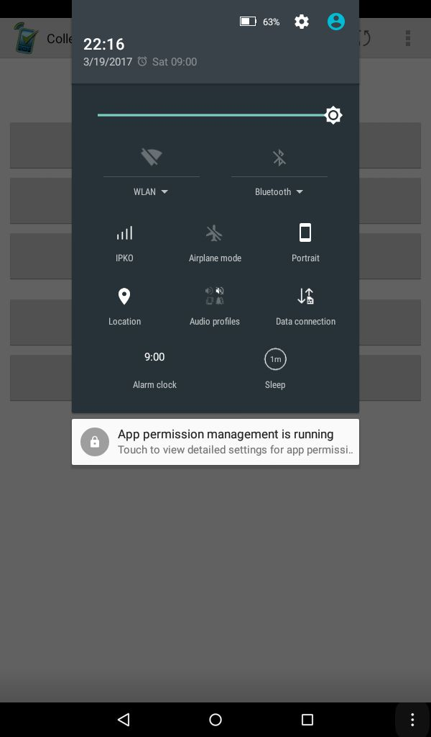

**Getting the form from the server**

Go to “Get Blank Form”, then select the name of the form and tap “Get Selected”.

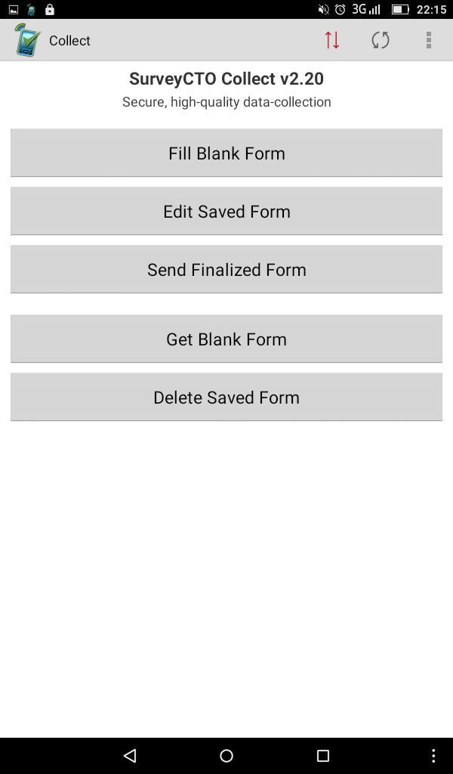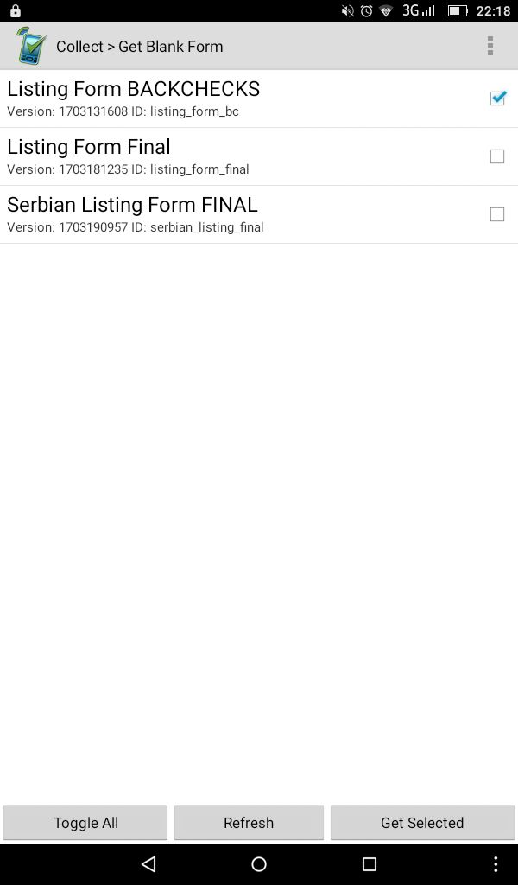

**Selecting a form to fill out**

Go to “Fill Blank Form” and select the form you want to fill.



**Saving the form after finishing the interview**

At the end of the interview click on “Save Form and Exit”. This will automatically save the form and upload it to the server. Note that you can’t make any changes to the form after you have uploaded it to the server.

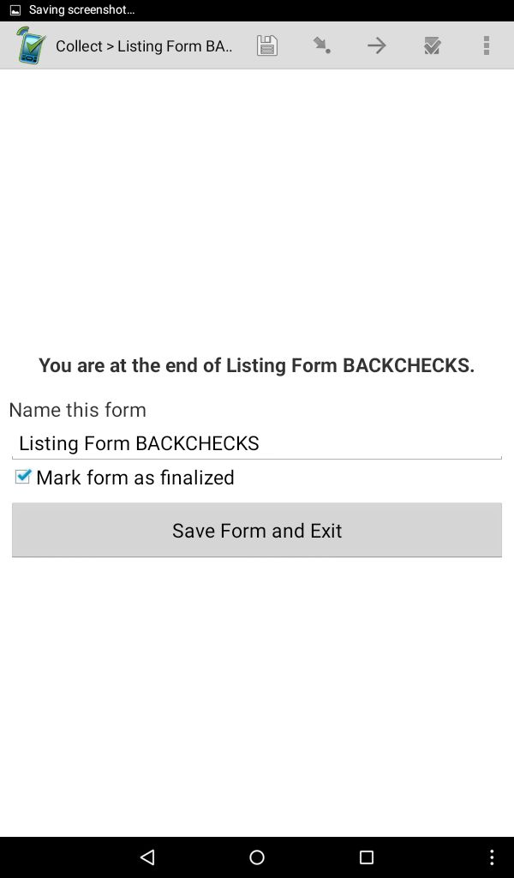

**In cases where the interview has to be discontinued midway and you have to re-visit later to resume the interview**

1. Tap the “Save” icon to save all responses collected up to that point
2. When you come back to resume the interview, go to “Edit Saved Forms” and select the form, then tap “Go to End”. The tablet will send you to the question where you left off.

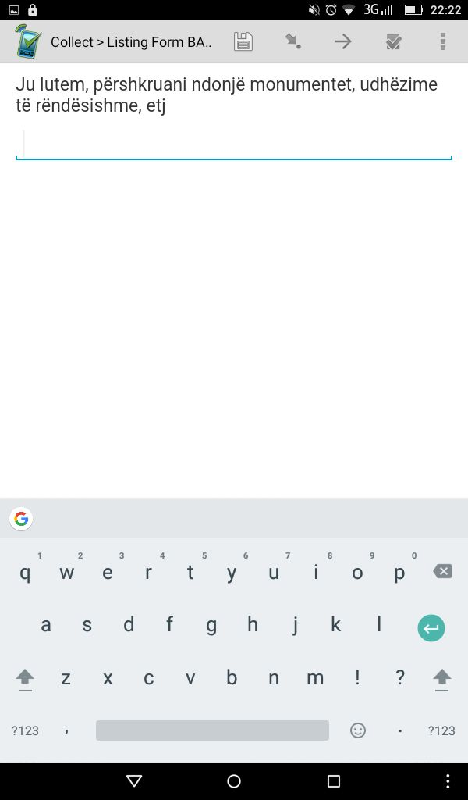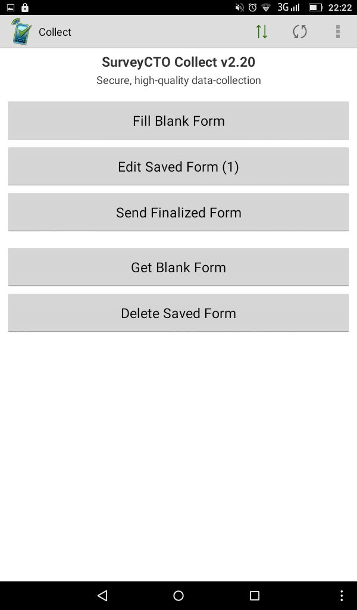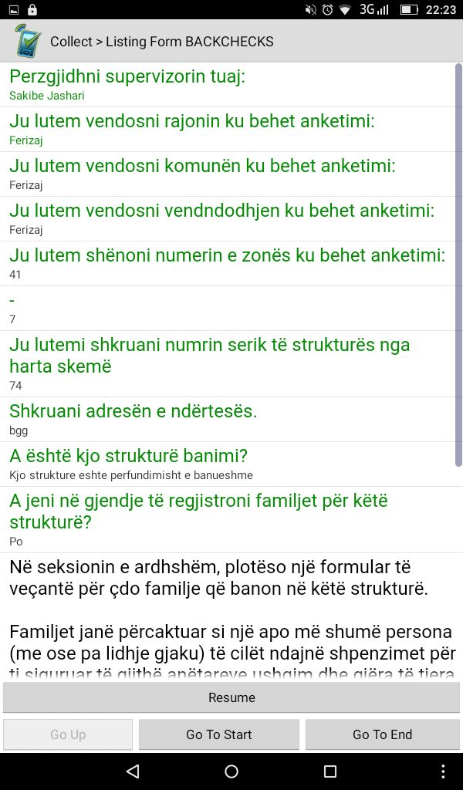

**In cases when you have started the interview with a respondent, but after answering a few questions they decide to abandon the interview and refuse to answer any more questions at that time or later**

Go to the “Back” button, then click “Ignore Changes” and tap “Yes I’m Sure”.

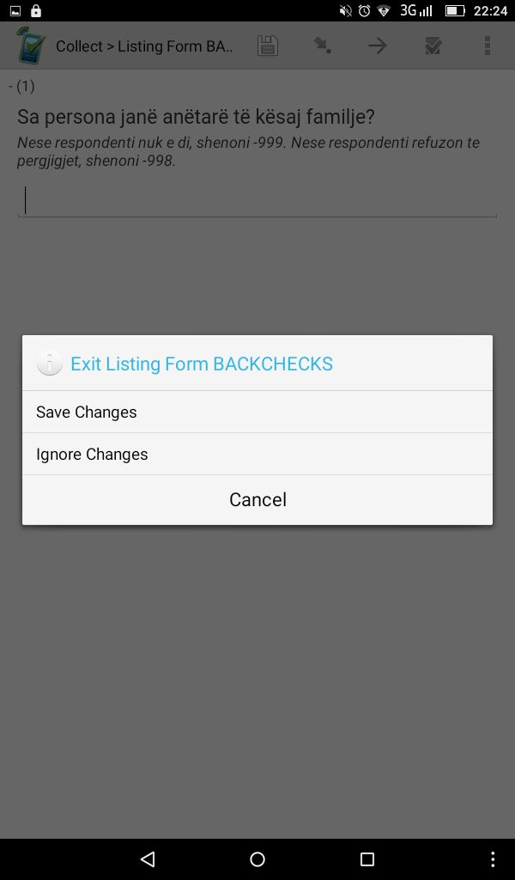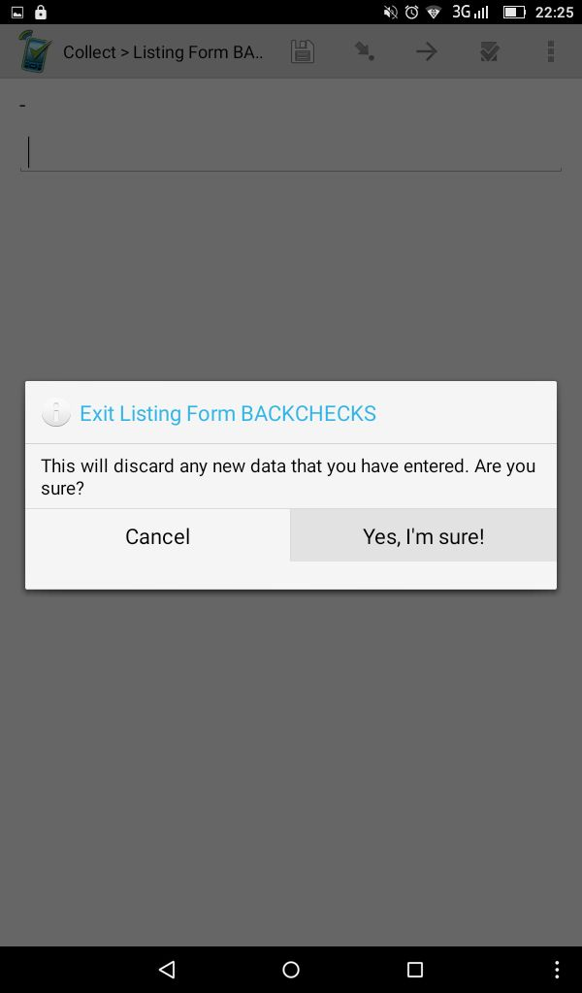

**Whenever any updates are made to the form, you will be required to install the updates to your tablet. You can do this by following the below steps:**

A new line named “Install Updates” will appear above “Fill Blank Form”. Immediately select it and hit “OK ”.

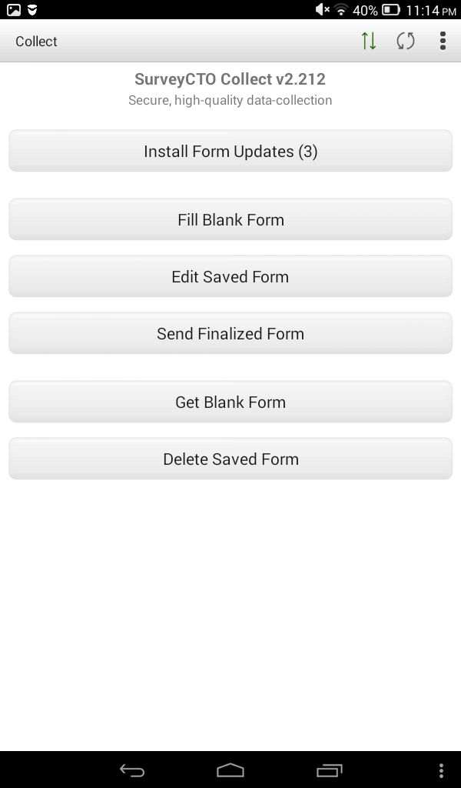

# Human Subjects Research Protections[2]

Research with human subjects can occasionally result in a dilemma for investigators. When the goals of the research are designed to make major contributions to a field, such as improving the quality of nationwide economic data, investigators may perceive the outcomes of their studies to be more important than providing protections for individual participants in the research. Although it is understandable to focus on goals, our society values the rights and welfare of individuals. It is not considered ethical behavior to use individuals solely as means to an end. The importance of demonstrating respect for research participants is reflected in the principles used to define ethical research and the regulations, policies, and guidance that describe the implementation of those principles.

Obtaining consent is one of the most important elements of protecting human subjects during research. In order to protect the respondents, you should read out the script that is programmed at the beginning of each survey to obtain informed consent from the respondents. You should take measures to maintain privacy and confidentiality during the interview. To the extent possible, the interviews should be administered separately, however if this is not possible you should make note of colocation.

# Data Quality Assurance

The study’s results will be used to directly inform growth-oriented policymaking in the development of the MCC Kosovo threshold program. The study is designed to increase the quality of economic data in Kosovo and answer research questions focusing on labor market participation, employment, time use, and workforce gender dynamics. Give the high impact potential of this study, it is of utmost importance that the data collected by this survey is of very high quality. There will be monitoring and data quality protocols in place to ensure the integrity of the data, throughout the data collection activity. Below are some ways in which this will be achieved:

Real-Time Data Monitoring: All data collected on the tablets will be reviewed by field supervisors and SI staff on the SurveyCTO online platform daily to ensure that all surveys are being administered appropriately. In the event of poor quality data, re-interviews will be conducted.

Accompaniments:Supervisors will accompany enumerators to 10% percent of their interviews. During each accompaniment, the supervisor will fill out an electronic accompaniment form rating the enumerator’s performance. Supervisors will give enumerators feedback on their performance, give them re-training or take disciplinary action if required. Supervisors will also record geocoordinates which will be cross-checked with the geocoordinates recorded by the enumerators.

Spot Checks: Supervisor will make unannounced visits to the field in order observe whether or not enumerators are present, administering the interviews properly and following all protocols.

Backchecks: Backchecks will be conducted on 10% of the interviews for each enumerator. They will be conducted both in-person and by telephone for attempted households as well as successfully enumerated households. During these backchecks, household will be asked whether not they were approached by enumerators, who they were approached by, and whether they completed the interview. They will also be asked a subset of questions from the survey. Data from back checks will be compared to the original data collected by enumerators to check for data falsification, mistakes, and need for potential retraining.

Independent Monitoring: There will also be a couple of independent data assurance specialist hired by SI who will engage in field-monitoring. In particular, they will conduct random spot checks, additional accompaniments and back checks, as well as participate in team debriefs.

Audio Audits:Audio for random sections of the survey will be recorded for 20% of the interviews. This is to ensure that the interviews are actually taking place, enumerators are administering questions correctly, prompting respondents for answers, and entering the responses appropriately.

# Tracking Protocols

The purpose of the tracking sheet is to record **all** contact attempts, successful or unsuccessful. The tracking sheet is a detailed record of interviewers’ movements in the field and experience at every attempt. It serves to:

* Show the number of attempts made in order to have a successful interview
* Remind the interviewer of appointments made earlier
* Indicate the reason why a given household was replaced
* Serve as a means of quality control
* Track response rates

Before knocking on a door, you should record on the tracking sheet the day and time of that specific visit AND the questionnaire serial number intended to be used for this visit. Then, depending on the outcome, you must indicate the results of the visit.

After an interview has been conducted successfully, you should record the outcome as successful and continue to the next household. However, there will be cases when the outcome is not successful. There are different reasons why an attempt might not be successful e.g. refusal by the household, respondents not being home, language barrier etc. Some reasons will require you to make a second or third visit at a given household while other reasons will require you to replace the household.

# Enumerator Conduct

**Voluntary informed consent**

You should ensure that survey participation from respondents is based on **voluntary informed consent**. You will establish informed consent by reading out a script from you tablet at the beginning of the survey that tells the respondent your full name, the fact that the interview is being conducted on behalf of MCC, the name of your company/agency (IDRA), the purpose of the study, the approximate length of the survey and the fact that participation is voluntary and confidential.

**Ethics and Protection of Human Subjects**

You should adhere to the following guidelines concerning your conduct and the confidentiality of the project:

* Ensure that survey participation from respondents is based on voluntary informed consent
* Be straightforward and honest in all professional and business relationships
* Be transparent as to the subject and purpose of data collection
* Respect the confidentiality of all information collected in your professional activities, this includes not passing on information about respondents to anyone
* Respect the rights and well-being of all individuals
* Ensure that respondents are not harmed or adversely affected by your professional activities.
* Ensure that you collect data per the training and instructions provided to you
* Protect the reputation and integrity of the profession
* Behave as a positive ambassador of IDRA remaining polite and professional at all times
* Be suitably dressed for the working environment to represent a good image of IDRA
* Collect data impartially and not influence their responses
* Do not share information about projects undertaken on behalf of IDRA with anyone outside the organization
* Take care to protect all materials provided to you including tablets, documents, household data, respondent gifts etc.

**Protection of Data and Confidentiality**

* All project information is strictly confidential.
* Any information disclosed to you is confidential to the Client, IDRA and its end Clients and will not be disclosed to any person or organization not involved in the study/project.
* You will not give respondents any indication of identity of the end Client unless required for survey technique or in compliance with data protection rules.
* The questionnaire and data remain the property of the Client at all times and may not be used, quoted or disclosed by you for any purpose other than for the execution of the relevant project.
* Under no circumstances should you disclose the following information to any third party:
  + The name, address, email address or telephone number of any person interviewed;
  + Any information collected from any person interviewed, regardless of whether that information relates to the person interviewed or to any other individual;
  + Any information that identifies any individual whose details the interviewer obtains during the course of their work.

# Interviewer Doorstep Techniques

In this section, we are detailing techniques that you should use in order to ensure that you are able to maximize response rate from households and members within the household. It is important that you follow the script the script provided to you, however, you can use the below techniques to encourage potential respondents to take part in the survey.

**Presenting yourself**

* Adopt a dynamic and self-confident tone; acting professionally is reassuring to potential respondents
* Be warm and smile!
* Introduce yourself: "Hello, I am (your first name and surname) from IDRA."
* State the object of your visit; stick to the script that has been provided to you and don’t make up things on your own
* Inform the potential respondent: "This involves just a few simple and fast questions on a topical subject".
* Use positive language; speak in the present indicative e.g. "Perhaps I could ask you the questions now...".
* Reassure the respondents (about the purpose of the visit, the confidentiality of their answers, etc.) by giving them your institute's contact details for any additional information they might want.

**Dealing with objections**

Some respondents may be reluctant to take part in a survey perhaps because they don't know you, are afraid of not knowing what information they will be asked to provide, are afraid of being judged, or can have a negative prejudice towards surveys in general. It is part of your responsibilities to reassure the respondent and make them want to answer! Listen carefully and be understanding to their concerns and try to respond according. You should practice and adapt your approach depending on the respondent and the circumstance.

Below are some examples of common scenarios and how to respond:

**Lack of time**: "I don't have the time"; "I'm in a hurry"; "I was just about to leave".

🡺 "I understand. You don’t have the time/ you're in a hurry/ you were just about to leave, but I just have some simple questions on your and your family’s labor status, and about your lifestyle and daily activities. The full survey will take between 30 minutes to an hour. I can make an appointment to come back when it is more convenient for you, but if you have a few minutes right now I would like to ask you a few questions to identify who is eligible for the interview. That will take about 10 to 15 minutes, and then I can come back later for the main survey?

**Hesitation:** "I don't know whether I'll be able to answer. It must be complicated."

🡺 "I understand your concern, but the questions are simple and there are no good or bad answers. Your opinions and the facts are the only thing that is important."

**Reluctance: “**I don’t know what my responses will be used for”

🡺 "Let me explain what it's all about. MCC is conducting a survey on employment and time use among Kosovo’s resident population. I am not selling anything; I would just like to ask about the situation of your family on this subject."

🡺 "I only want to ask your opinion and all your answers will be treated as statistical data and will remain confidential."

**Lack of interest:** "The subject doesn't interest me." Or “I don’t care about this survey”

🡺 "You represent a part of the population and information about you is therefore very important. Your response will help inform our study and future reform work to improve employment outcomes in Kosovo."

**Opposition to surveys:** Show that you are taking into consideration the reason given for not participating, using word for word what the person has just said and leading him/her immediately back to the reason for your call.

"I'm fed up with surveys"; "What good are surveys?"

🡺 “MCC is conducting a survey for the purpose of gathering information on employment and time use among Kosovo’s resident population We are interviewing a representative sample of the population. You represent a part of the population and information about you is therefore very important. Your response will help inform our study and future reform work to improve employment outcomes in Kosovo.”

Fear of door-to-door selling: “I am constantly being disturbed.”

🡺 “Your address was selected according to a random selection method. IDRA carries out surveys; the purpose of my visit is simply to ask you about your employment status and your main activities during the day. Don’t worry, I am not selling anything.”

🡺 “Let me assure you, IDRA does not sell anything. I simply would like to ask you some questions on this subject. Your answers are very important.”

“What proof do I have that this is for IDRA?”; “I’ve already had visits from salesmen who tried to pass themselves off as polltakers”; “It starts off as a survey and afterwards you'll have something to sell to me".

🡺 "I assure you, I work for IDRA. Here's my badge as proof. I suggest you call our number, which is [phone number]. This number is available for the people we interview, to reassure them about the purpose and the serious nature of our work."

🡺 "I assure you that my visit is not for commercial reasons and you'll see that for yourself in the questions I'm going to ask you. You will not be committing yourself to anything by answering. All your answers will be treated as statistical data and will remain confidential."

# Enumerator Responsibilities

You **MUST ALWAYS**:

* Comply to research ethics and protect respondents’ confidentiality;
* Take care of your safety and others while in the field;
* Introduce yourself and the study and negotiate access to the household (asking respondent’s choice of language for the interview) ;
* Minimize refusals by applying conversion techniques; avoid/resolve conflict;
* Go only to the indicated/given list of households/addresses provided;
* Comply with the respondent selection procedure;
* Fill out the tracking sheet for each contact made with the household;
* Review this manual and the questionnaires prior to going to the field;
* Follow instructions on the tablet, read questions verbatim, probe, record responses honestly and properly;
* Be familiar with tablet devices and CAPI features;
* Follow the workplan and respect the deadlines set by the supervisor/coordinator;
* Report to your supervisor and coordinator for challenges faced in the field and any adverse or unusual circumstances.

You must **NEVER**:

* Violate respondent confidentiality in any way;
* Explain a question. If a respondent doesn’t understand the question, patiently offer to reread it. If the respondent still doesn’t understand, code this as a “don’t know” response and continue;
* Interpret any terms. If the respondent asks for a definition, simply respond that none is provided and encourage them to respond according to their own interpretation;
* Assume to know how a respondent will respond;
* Decide to skip a household or even a neighborhood because of the way it looks (either too poor or too rich);
* Skip questions that should not be skipped according to instructions on the survey;
* Lead the respondent or suggest they answer in a particular way;
* Share your own opinions or those of other respondents;
* Translate any terms into another language unless you have another language version of the questionnaire that has already been approved. If the respondent does not understand the terms, encourage the respondent to answer the questions according to their own interpretation;
* Allow someone other than the randomly selected respondent to complete the survey;
* Let another member of the household respond as a proxy for the selected respondent;
* Read text in parentheses/italics out loud to the respondent.

# Supervisor Responsibilities

There will be 7 supervisors in total and each supervisor will be responsible for 2 enumeration teams made up of 4 enumerators. Their responsibilities include:

* Ensure that all materials (Surveyor Manual, Sketch Maps, Tracking Sheets, and Interviewing Tablet Forms) are obtained and current before going to the field;
* Plan and organize fieldwork logistics (e.g., arranging for transport, identifying and contacting local officials and village elders in each cluster to inform them about the survey and to obtain their cooperation);
* Make sure that their teams complete all interviews for each EA within the two days assigned;
* Be present in the field to monitor and verify that the quality of work is acceptable;
* Accompany enumerators to at least 10% percent of their interviews during which they will fill out an electronic accompaniment form rating the enumerator’s performance and capturing geocoordinates;
* Provide feedback and re-training to enumerators and take disciplinary action when needed
* Conduct random unannounced spot checks for at least 10% of their interviews;
* Debrief with their teams at the end of each day of data collection and provide guidance on any issues that arose that day such as administering certain survey questions, finding/tracking respondents, dealing with problematic situations etc.;
* Submit a weekly report of problems, resolutions and next steps;
* Collect and monitor tracking sheets to record all contact attempts, reasons for replacement and enumerator movements in the field.

# Education Field Examples

When administering the Household Roster, you will be required to code the field of study of the household members. The below table will help you code respondents’ answers into education cateogries:

|  |  |  |
| --- | --- | --- |
| **Field of Education Code** | **Narrow Field** | **Detailed Field** |
| **1 General programs** | Basic programs and qualifications  Literacy and numeracy  Personal skills and development | Basic programs and qualifications  Literacy and numeracy  Personal skills and development |
| **2 Teacher training and education science** | Education | Education science  Training for pre-school teachers  Teacher training without subject specialization  Teacher training with subject specialization |
| **3 Humanities, languages and arts** | Arts  Humanities  Languages | Audio-visual techniques and media production  Fashion, interior and industrial design  Fine arts  Music and performing arts  Religion and theology  History and archaeology  Philosophy and ethics  Language acquisition  Literature and linguistics |
| **4 Social sciences** | Social and behavioral sciences  Journalism and information | Economics  Political sciences and civics  Psychology  Sociology and cultural studies  Journalism and reporting  Library, information and archival studies |
| **5 Business** | Business and administration | Accounting and taxation  Finance, banking and insurance  Management and administration  Marketing and advertising |
| **6 Law** | Law | Law |
| **7 Life science (including biology and environmental science)** | Biological and related sciences  Environment | Biology  Biochemistry  Environmental sciences  Natural environments and wildlife |
| **8 Physical science (including physics, chemistry, and earth science)** | Physical sciences | Chemistry  Earth sciences  Physics |
| **9 Mathematics and statistics** | Mathematics and statistics | Mathematics  Statistics |
| **10 Computer science** | Information and Communication Technologies (ICTs) | Computer use  Database and network design and  administration  Software and applications development and analysis |
| **11 Computer use** | Computer use | Computer use |
| **12 Engineering** | Engineering and engineering trades | Chemical engineering and processes  Environmental protection technology  Electricity and energy  Electronics and automation  Motor vehicles, ships and aircraft |
| **13 Manufacturing and construction** | Manufacturing  Architecture and construction | Manufacturing (non trades)  Mining and extraction  Architecture and town planning  Building and civil engineering |
| **14 Agriculture and veterinary** | Agriculture  Forestry  Fisheries  Veterinary | Crop and livestock production  Horticulture  Forestry  Fisheries  Veterinary |
| **15 Health and welfare** | Health  Welfare | Dental studies  Medicine  Nursing and midwifery  Medical diagnostic and treatment technology  Therapy and rehabilitation  Pharmacy  Traditional and complementary medicine and therapy  Care of the elderly and of disabled adults  Child care and youth services  Social work and counselling |
| **16 Crafts and trades** | Crafts and trades | Mechanics and metal trades  Handicrafts  Electrician and electronic trades  Food processing  Materials (glass, paper, plastic and wood)  Textiles (clothes, footwear and leather) |
| **17 Administrative and clerical** |  | Secretarial and office work  Wholesale and retail sales  Work skills |
| **18 Services** | Personal services  Hygiene and occupational health services  Security services  Transport services | Domestic services  Hair and beauty services  Hotel, restaurants and catering  Sports  Travel, tourism and leisure  Community sanitation  Occupational health and safety  Military and defence  Protection of persons and property  Transport services |

# TUS Coding Guidelines[3]

**Activity codes:** At the end of each day, you are responsible for converting the open response for each 15-minute segment into one of the 2008ACL activity codes according to the guidelines below and then entering them into the tablet.

|  |  |
| --- | --- |
| *Category* | *2008ACL Activity Codes* |
| **Personal Care** | 0.1.1 sleep  0.1.2 sick in bed  0.2.1 eating  0.3.1 washing and dressing  0.3.9 other or unspecified personal care |
| **Employment** | 1.1.1 working time (including coffee breaks and travel at work)  1.2.1 activities related to employment – lunch break  1.2.2 activities related to employment – job search  1.2.9 activities related to employment – other or unspecified |
| **Studying** | 2.0.0 unspecified study  2.1.1 school or university – classes and lectures  2.1.2 school or university – homework  2.2.1 free time study |
| **Household and Family Care** | 3.1.1 food preparation, baking and preserving  3.1.2 dish washing  3.8.1 childcare – physical care and supervision  3.8.2 childcare – teaching the child  3.8.3 childcare – reading, playing and talking with child  3.8.4 childcare – accompanying child  3.8.9 childcare – other or unspecified  3.9.1 help to adult family member – physical care of dependent adult hh member  3.9.2 help to adult family member – other help of dependent adult hh member  3.9.9 help to adult family member – help to non-dependent adult hh member  3.2.1 household upkeep - cleaning dwelling  3.2.2 household upkeep - cleaning garden  3.2.3 household upkeep - heating and water  3.2.4 household upkeep - arranging household goods and materials  3.2.9 household upkeep – other or unspecified  3.3.1 making and care for textiles – laundry  3.3.2 making and care for textiles - ironing  3.3.3 making and care for textiles – handicraft and producing textiles  3.3.9 making and care for textiles – other or unspecified  3.4.1 gardening and pet care - gardening  3.4.2 gardening and pet care – tending domestic animals  3.4.3 gardening and pet care – caring for pets  3.4.4 gardening and pet care – walking the dog  3.4.9 gardening and pet care – other or unspecified  3.5.1 construction and repairs – house construction and renovation  3.5.2 construction and repairs – repairs to dwelling  3.5.3 construction and repairs – making, repairing and maintaining equipment  3.5.4 construction and repairs – vehicle maintenance  3.5.9 construction and repairs – other or unspecified  3.6.1 shopping and services – shopping  3.6.2 shopping and services – commercial and administrative services  3.6.3 shopping and services – personal services  3.6.9 shopping and services – other or unspecified  3.7.1 household management  3.0.0 Unspecified household and family care |
| **Voluntary work and meetings** | 4.1.1 Organizational work (work for or through an organization)  4.2.1 Informal help to other households – construction and repairs as help  4.2.2 Informal help to other households – help in employment and farming  4.2.3 Informal help to other households – care of own children living in another hh  4.2.4 Informal help to other households – other childcare as help to another hh  4.2.5 Informal help to other households – help to an adult of another hh  4.2.9 Informal help to other households – other or unspecified  4.3.1 participatory activities – meetings  4.3.2 participatory activities – religious activities  4.3.9 participatory activities – other or unspecified |
| **Social life and entertainment** | 5.1.1 social life – socializing with family  5.1.2 social life – visiting and receiving visitors  5.1.3 social life – celebrations  5.1.4 social life – telephone conversation  5.1.9 social life – other or unspecified  5.2.1 entertainment and culture – cinema  5.2.2 entertainment and culture – theater and concerts  5.2.3 entertainment and culture – art exhibitions and museums  5.2.4 entertainment and culture – library  5.2.5 entertainment and culture – sports events  5.2.9 entertainment and culture – other or unspecified  5.3.1 resting – time out |
| **Sports and outdoor activities** | 6.1.1 physical exercise – walking and hiking  6.1.2 physical exercise – jogging and running  6.1.3 physical exercise – cycling, skiing and skating  6.1.4 physical exercise – ball games  6.1.5 physical exercise – gymnastics and fitness  6.1.6 physical exercise – water sports  6.1.9 physical exercise – other or unspecified  6.2.1 productive exercise (hunting, fishing, picking berries, mushrooms, herbs)  6.3.1 sports related activities |
| **Hobbies and computing** | 7.1.1 arts and hobbies – arts (visual, performing, literary)  7.1.2 arts and hobbies – collecting  7.1.3 arts and hobbies – correspondence  7.1.9 arts and hobbies – other or unspecified  7.2.1 computing – programming  7.2.2 computing – information by computing  7.2.3 computing – communication by computing  7.2.9 computing – other or unspecified  7.3.1 games – solo games and playing, gambling  7.3.2 games – parlor games and play  7.3.3 games – computer games  7.3.9 games – other or unspecified |
| **Mass media** | 8.1.1 reading – periodicals  8.1.2 reading – books  8.1.9 reading – other or unspecified  8.2.1 watching tv, video or DVD  8.3.1 listening to radio or recordings |
| **Travel** | 9.1.0 travel –to/from work  9.2.0 travel – related to study  9.3.6 travel – related to shopping and services  9.3.8 travel – related to childcare  9.3.9 travel – related to other household care  9.4.0 travel – related to voluntary work and meetings  9.5.0 travel – related to social life  9.6.0 travel – related to other leisure  9.8.0 travel – related to changing locality  9.0.0 travel – other or unspecified |
| **Other** | 9.9.8 auxiliary codes – unspecified leisure time  9.9.9 auxiliary codes – other |

# Frequently Asked Questions (FAQs)

**Q: What should I do if the respondent is not able to communicate in the language the survey is in?**

Record “language barrier” on the tracking sheet and record the language the respondent speaks. In mixed EAs when the respondent language is eligible for the survey (Albanian or Serbian), the enumerator should notify their supervisor immediately to send an interviewer who fluently speaks that language. In cases when the language does not match any of the survey languages, you should replace the household. NEVER try to translate the survey questions in a different language.

**Q: What should I do if another member of the household volunteers to give responses for the selected respondent?**

Due to cultural norms in some regions of Kosovo, male members in the household may volunteer to provide responses on behalf of the selected female respondent. You should politely turn down that offer and conduct the interview with the selected female respondent or record refusal and move to the next eligible household. Do not accept proxy respondents.

**Q: Which family members should I include in the Pre-screening? Should I exclude family members above the age of 64 because they are not eligible for the extended interview?**

You should include ALL members equal to or above the age of 15 in the pre-screening. The tablet form will itself determine who is eligible for the extended interview and display it as a list at the end of the screening which you will then note down in your tracking sheet for the household

**Q: How many tracking sheets should I fill out for each household? If a household get replaced, should I fill out the same tracking sheet for the replacement household?**

You should fill out ONE tracking sheet per household which is made up of the following: 1) household tracking sheet, 2) household roster tracking sheet and 3) extended interview tracking sheet. If a household gets replaced, note down the code for why that household was replaced. Then, fill out a NEW tracking sheet for the replacement household whenever you reach that household to conduct interviews.

**Q: If the respondent does not understand the question the first time, should I paraphrase?**

If the respondent does not understand the question the first time, repeat the question as it is written in the tablet. If the respondent still does not understand, leave it up to their interpretation and record whatever response they give. Do NOT paraphrase under any circumstances.

**Q: What should I do if I mistakenly visit a household close to the one I had to visit and submit the forms? Should I complete 11 HH forms in that Enumeration Area (EA) then?**

Use the sketch maps provided to you in order to accurately locate the household you are supposed to interview. If you mistakenly interview the wrong household, you will have to go back to the original household that you were supposed to visit and submit new forms. Please let your supervisor know if this happens.

**Q: Should I enter the full name or just the first name of the interviewee in the questionnaire?**

You are only required to enter the first name of the family member in the questionnaire.

# ****Annotated Questionnaires****

We will provide detailed instructions on how to fill out responses for certain questions. All questionnaires including the Household Roster, Extended Interview and Time Use Diary will be provided to you during the training.

1. <http://ec.europa.eu/eurostat/statistics-explained/index.php/EU_labour_force_survey_-_methodology>
2. https://phrp.nihtraining.com/users/PHRP.pdf
3. http://ec.europa.eu/eurostat/ramon/statmanuals/files/KS-RA-08-014-EN.pdf